CREATE table Time_dw

( time_id int PRIMARY KEY,

day DATE NOT NULL,

month varchar(255) NOT NULL,

qt varchar(255) NOT NULL,

yr varchar(255) NOT NULL);

INSERT INTO Time_dw(time_id,day, month,qt,yr)

VALUES (101, '2021-01-17', 'january', 'Q1','2021');

INSERT INTO Time_dw(time_id, day, month,qt,yr)

VALUES (102, '2021-02-14', 'february', 'Q1','2021');

INSERT INTO Time_dw(time_id, day, month,qt,yr)

VALUES (103, '2021-05-21', 'may', 'Q2','2021');

INSERT INTO Time_dw (time_id, day, month,qt,yr)

VALUES (104, '2021-06-26', 'june', 'Q2','2021');

select * from Time_dw;

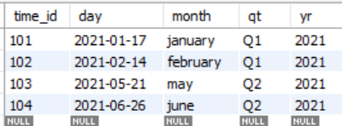

CREATE table Product_dw

( prod_id int PRIMARY KEY,

Prod_name varchar(60) NOT NULL,

Prod_category varchar(255) NOT NULL,

Brand_name varchar(255) NOT NULL,

Suppl_name varchar(255) NOT NULL,

Prod_price int );

INSERT INTO product_dw(prod_id,Prod_name,Prod_category,Brand_name, Suppl_name,Prod_price)

VALUES (1, 'rice', 'grocery', 'Dawat','Ramesh',140 );

INSERT INTO product_dw(prod_id,Prod_name,Prod_category,Brand_name, Suppl_name,Prod_price)

VALUES (2, 'Sugar', 'Grocery', 'Dawat','Ramesh',50 );

INSERT INTO Product_dw (prod_id,Prod_name,Prod_category,Brand_name, Suppl_name, Prod_price)VALUES (3, 'Kurta', 'Cloth', 'Max','Lila',500 );

INSERT INTO product_dw(prod_id,Prod_name,Prod_category,Brand_name, Suppl_name,Prod_price)

VALUES (4, 'jacket', 'Cloth', 'Max','Lila',700 );

select * from product_dw

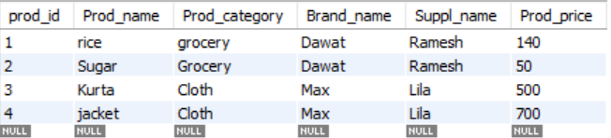

CREATE table Location_dw

(loc_id int PRIMARY KEY,

street varchar(60) NOT NULL,

city varchar(255) NOT NULL,

state varchar(255) NOT NULL,

country varchar(255) NOT NULL);

INSERT INTO Location_dw(loc_id,street,city,state,country)

VALUES (201,'MLROAD','MUMBAI','MAHARASHTRA','INDIA');

INSERT INTO Location_dw(loc_id,street,city,state,country)

VALUES (202,'AIROAD','MUMBAI','MAHARASHTRA','INDIA');

INSERT INTO Location_dw(loc_id,street,city,state,country)

VALUES

(203,'BIROAD','KOLKATA','WESTBENGAL','INDIA');

INSERT INTO Location_dw(loc_id,street,city,state,country)

VALUES (204,'DB ROAD','KOLKATA','WESTBENGAL','INDIA');

select * from Location_dw;

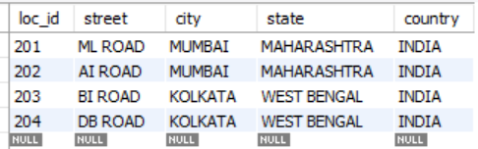

CREATE table Fact_sales

(prod_id int REFERENCES Product_dw(prod_id),

time_id int REFERENCES Time_dw(time_id),

loc_id int REFERENCES Location_dw(loc_id),

number_of_unit_sold int NOT NULL,

Total_sales int NOT NULL);

INSERT INTO Fact_sales

(prod_id,time_id,loc_id,number_of_unit_sold,Total_sales)

VALUES (1,104,201,400,90000);

fact_sales

select * from Fact_sales;

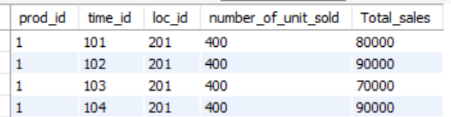

**Roll Up**

SELECT yr, SUM(total_sales)

FROM (Fact_sales NATURAL JOIN Product_dw)

JOIN

Time_dw ON Fact_sales.time_id=Time_dw.time_id

GROUP BY yr;

**OR**

Select Time_dw.yr, sum(total_sales)

From Fact_sales

JOIN Product_dw ON

Fact_sales.product_id = Product_dw.product_id

JOIN Time_dw ON fact_sales.time_id= time_dw.time_id

Group by time_dw.yr;

Or

Select time.yr, sum(total_sales)

From sales

JOIN product ON

sales.prod_id = product.prod_id

JOIN time ON sales.time_id= time.time_id

Group by time.yr;



**Drill Down**

SELECT time_dw.qt,SUM(total_sales)

FROM (Fact_sales NATURAL JOIN Product_dw)

JOIN Time_dw ON Fact_sales.time_id=Time_dw.time_id

GROUP BY time_dw.qt;

OR

Select time_dw.qt,sum(total_sales)

From Fact_sales JOIN Product_dw

ON Fact_sales.product_id = Product_dw.product_id

JOIN Time_dw ON fact_sales.time_id= time_dw.time_id

Group by time_dw.qt;

OR

Select time_dw.qt,sum(total_sales)

From sales_fact JOIN Product_dw

ON sales_fact.product_id = Product_dw.product_id

JOIN Time_dw ON sales_fact.time_id= time_dw.time_id

Group by time_dw.qt;

Or

Select time.qt,sum(total_sales)

From sales JOIN product

ON sales.prod_id = product.prod_id

JOIN time ON sales.time_id= time.time_id

Group by time.qt;

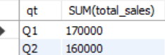

**Pivot**

SELECT yr, month,qt

FROM Time_dw as source_table

**Or**

SELECT yr, month,qt

FROM time as source_table

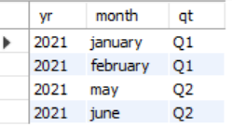

**Slice**

SELECT Prod_name ,Total_sales

FROM Fact_sales

INNER JOIN Product_dw

ON Fact_sales.prod_id=Product_dw.prod_id

or

SELECT prod_name ,total_sales

FROM sales

INNER JOIN product

ON sales.prod_id=Product.prod_id

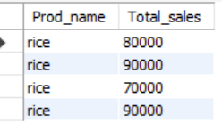

**DICE**

SELECT Prod_name ,Total_sales ,day

FROM ((Fact_sales

INNER JOIN Product_dw

ON Fact_sales.prod_id =Product_dw.prod_id) JOIN Time_dw

ON Fact_sales.time_id =Time_dw.time_id)

Or

SELECT Product_name ,total_sales ,day

FROM ((sales_fact

INNER JOIN product_dw

ON sales_fact.product_id =product_dw.product_id) JOIN Time_dw

ON sales_fact.time_id =Time_dw.time_id)

Or

SELECT prod_name ,total_sales ,day

FROM ((sales

INNER JOIN product

ON sales.prod_id =product.prod_id) JOIN time

ON sales.time_id =time.time_id)

